


46 Korella st
Mullaloo
WA, 6027,
Tel :(08)9403 0699
Fax :(08)9403 0799
info@jckdistributors.com.au

Bio-Bitumen Remover TDS
Description: Bitumen and asphalt remover

Intended Use
Bio-Bitumen Remover an effective bitumen and asphalt remover with a variety of applications from cleaning truck beds and spray bars, pavers, tools, manhole covers and kerb stones.
Features
- Bio-Bitumen Remover is derived primarily from natural edible plant oils
- Free of VOC and the customary traditional solvents.
- Works to remove bitumen from trucks, kerbs, and manhole covers.
- Safe product to use, eliminate hazards such as explosions, noxious fumes and carcinogens that can result from traditional solvents, kerosene and diesel.
- Similar molecular structure to bitumen allows rapid and efficient penetration through the bitumen and asphalt.
Sizes
5L, 10L, 20L, 200L, 1000L
Physical Properties
Appearance & Odour | Pale yellow-brown mobile liquid. Mild Odour
Boiling Point | >200 ºC
Flash Point | >190ºC (COC)
pH (neat) | 8-8.5
Solubility in Water | The product is soluble in water.
Specific Gravity | .90

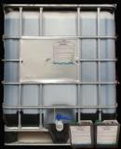

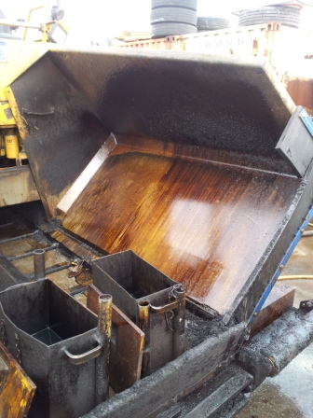
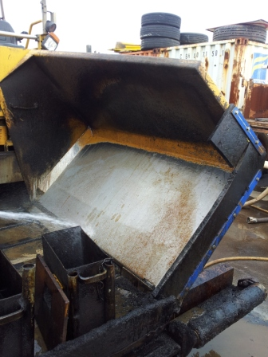
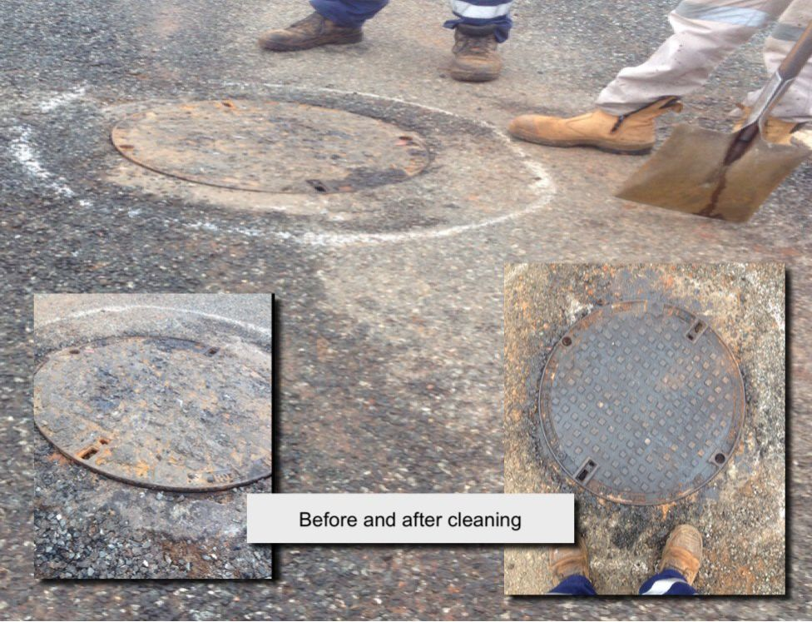
ALWAYS TEST FIRST ON A SMALL INCONSPICUOUS AREA.
Please contact our representatives for guidance, assistance and further technical information which is available through your local agent or via our Web site www.jckdistributors.com.au
About Bio- Bitumen Remover
Bio-Bitumen Remover has a similar molecular structure to bitumen, resulting in the rapid penetration of the bitumen.
Bitumen and asphalt is quickly softened and loosened, Bio-Bitumen Remover works effectively to remove asphalt from kerb stones, steel, paint work and glass.
Upon being washed off the bitumen particles are held in solution on the surface allowing it to be removed to waste or can be separated, allowing the bitumen to be recycled
Application Instructions:
Best results have been achieved once dust and mud have been removed and the surface allowed to dry.
1) Apply Bio-Bitumen Remover with a hand held pressure fogging spray and allow penetrate for 15 to 20 minutes.
2) Rinse off with a high pressure spray preferably using hot water.
3) Heavily encrusted areas may need a second application to allow Bio-Bitumen Remover to penetrate fully.
Ensure the bitumen/ Asphalt coated surface is dry.
Thick build up may need multiple coats.
Applied to metal parts such as spray bars Bitumen Remover can be left to soak for hours.
When applying to plastic/paint ensure you follow application guidelines.

