
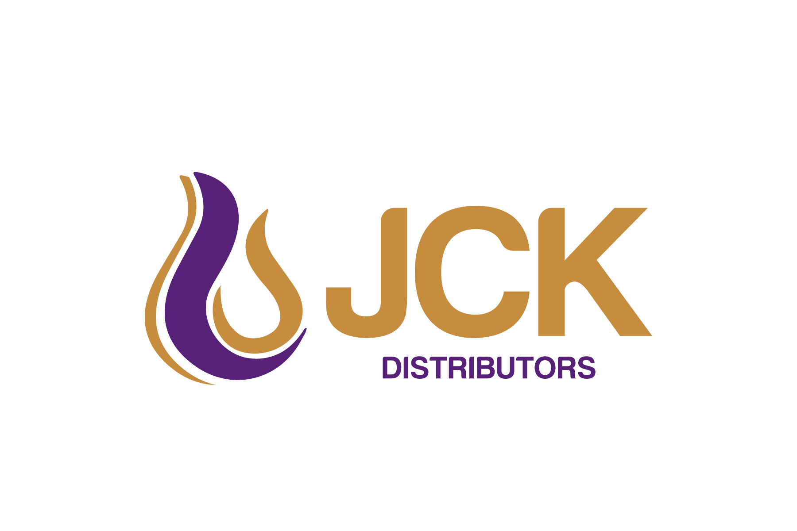

46 Korella st
Mullaloo
WA, 6027,
Tel :(08)9403 0699
Fax :(08)9403 0799
info@jckdistributors.com.au

BlackJack Remover TDS
Description: Heavy grease remover

Intended Use
Ideal for removal of grease and bitumastic soils,

Features & Benefits
- Solvent free
- Effective cleaning in heavy duty applications – removes heavy grease and blackjack from metal surfaces
- Maintains vehicle cleanliness and will remove bitumen from road-going vehicles
- Contains biodegradable emulsifiers
- BlackJack Remover is derived primarily from natural edible plant oils
- Free of VOC’s.
- Works to remove bitumen and Blackjack greases from trucks and machinery, kerbs, and manhole covers, drill pipes.
- Safe product to use, eliminate hazards such as explosions, noxious fumes and carcinogens that can result from using traditional solvents, kerosene or diesel.
- Similar molecular structure to bitumen allows rapid and efficient penetration through the soiled material.
Sizes, 20L, 200L, 1000L
Physical Properties
Appearance & Odour | Pale yellow-brown mobile liquid. Mild Odour
Boiling Point | >200 ºC
Flash Point | >190ºC (COC)
pH (neat) | 8-8.5
Solubility in Water | The product is insoluble in water.
Specific Gravity | .90

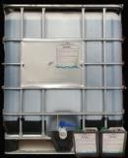

ALWAYS TEST FIRST ON A SMALL INCONSPICUOUS AREA.
Please contact our representatives for guidance, assistance and further technical information which is available through your local agent or via our Web site www.jckdistributors.com.au

BlackJack Remover is a Quick Break product and is suitable for oil/water separators
Application Instructions:
Best results have been achieved once dust and mud have been removed and the surface allowed to dry.
1) Apply BlackJack Remover with a hand held pressure spray or brush and allow to penetrate for 15 to 20 minutes.
2) Rinse off with a high pressure spray preferably using hot water.
3) Heavily encrusted areas may need a second application to allow BlackJack Remover to penetrate fully.
4) Ensure item/vehicle is completely free of water before re/applying
Ensure the material surface is free of water.
Thick build up may need multiple coats.
When applied to unpainted metal parts BlackJack Remover can be left to penetrate overnight.
When applying to plastic/paint ensure you follow application guidelines.

